

Name - Aniket Sonu
Student Id - GH1048274
Email Id – Aniket.Sonu@gisma-student.com
Dissertations - Prioritization of Regression Testing Using Machine Learning

Course Name - M598 Master's Thesis (SS0626)

Project URLs:
GitHub Link - GitHub - AniketSonu/ThesisProject · GitHub
Submission Date – 24-Sep-2026

Prioritization of Regression Testing Using Machine Learning

INDEX

Abstract
Chapter 1: Introduction
Chapter 2: Foundations and Background
Chapter 3: Related Work
Chapter 4: Research Approach and Technical Implementation
Chapter 5: Evaluation and Results
Chapter 6: Conclusion and Future Work
References

Abstract

As modern software grows bigger and more advance, keeping up with quality assurance has become a major headache for development teams. The main part of the problem is testing and retesting all the same code without knowing which testcase is effect to bug finding and which one is wase of time and resources. Traditional testing approaches increase the testing time, higher costs, and delayed software releases. To overcome these challenges, this research proposes a machine learning-based framework of regression test prioritization using machine learning algorithm that predicts the ranks of test cases according to their probability of bug prediction. This approach aims the correct sequence of testing in test suite so we will get more bugs in less execution and save lot of time.
I built this model using a Software Defect Prediction with metrics that capture different attributes of software modules. Before training, we cleaned and preprocessed the data to make sure our predictions would be reliable. This involved using median imputation to fill in missing values, converting defect labels into standard binary format, and assigning unique IDs to every test case. Like most real-world defect datasets, ours was heavily imbalanced—non-defective instances far outnumbered the defective ones. To stop the model from developing a bias toward the safe majority and missing actual bugs, we use the Synthetic Minority Over-sampling Technique (SMOTE). This balanced the training dataset so the model could learn to spot defective software much more effectively.
To find the best model, three widely used supervised algorithm taken randomly and the models are: Support Vector Machines (SVM), Random Forest, and XGBoost. Also applied hyperparameter tuning using the GridSearchCV and 5-fold Stratified Cross-Validation, guaranteeing we found the best settings while keeping class proportions balanced during training. This framework calculates a custom decision threshold for each model by maximizing the F1-score through Precision-Recall curve analysis. Fine-tuning the threshold way creates a better balance between catching actual bugs and avoiding false alarms, making the system far more practical for real-world software testing.4
By evaluating the models using standard classification metrics, including Accuracy, Precision, Recall, F1-score, ROC-AUC, confusion matrices, and detailed classification reports. In this program I prioritize the Recall and F1-score—in software testing, missing a critical bug is far more costly than getting a false alarm on clean code.
We then used the winning model to estimate the failure probability of every test case in the dataset. By ranking the test cases from highest to lowest risk, we enabled testing teams to run the most defect-prone tests first. To measure how well this ranking actually worked, we evaluated it using the Average Percentage of Faults Detected (APFD) metric, which tracks how quickly bugs are uncovered during execution. By combining defect prediction wdeith smart test case prioritization, this approach shows how machine learning can streamline testing strategies and catch critical faults much earlier.
The primary contribution of this research is an end-to-end machine learning framework that brings data preprocessing, SMOTE imbalance handling, hyperparameter optimization, threshold tuning, defect prediction, and automated test case prioritization into a single, seamless workflow. Rather than stopping at basic defect classification, our system directly aids testing teams by turning raw failure probabilities into actionable, prioritized test case lists. The results show that bringing machine learning into the testing loop speeds up bug detection and optimizes resource use. This framework offers a practical blueprint for teams wanting to move toward data-driven QA, with clear potential for expansion into deep learning models, advanced ensemble techniques, and CI/CD pipelines.

Chapter 1: Introduction

1.1 Introduction
Software is playing an essential role in modern society, supporting applications in healthcare, banking, transportation, education, manufacturing, and communication. As software systems continue to increase in size and complexity, confirming their reliability has become one of the primary objectives of software engineering. Software defects, commonly referred to as bugs or faults, can reduce system performance, compromise security, and lead to financial losses or safety risks. So, software testing plays a critical role in identifying defects before software is released to production users. However, traditional software testing needs large time, cost, and human effort because thousands of test cases may need to be executed during each testing cycle. Software engineering has evolved from developing relatively simple standalone applications to creating highly interconnected systems that operate across cloud platforms, mobile devices, embedded systems, and distributed networks. These modern systems often interact with external services through application programming interfaces (APIs), making software behavior more complex and increasing the possibility that a small change in one component may affect multiple parts of the system.
An important challenge in software testing is that not all software modules have the same chance of defects. Similarly, not all test cases have same defect to bug detection. Executing every test case with equal priority can delay the discovery of critical defects and reduce the efficiency of the testing process. With the increasing availability of historical software metrics and testing data, machine learning has developed as a promising solution for predicting defect-prone software modules and supporting intelligent testing decisions. By learning patterns from previous software defects, machine learning models can estimate which software components are most likely to fail and help testers focus their efforts on high-risk areas first.
This dissertation investigates the application of machine learning technique for test case prioritization in regression testing. The proposed framework combines data preprocessing, class imbalance handling, supervised machine learning models, hyperparameter optimization, and performance evaluation to create a practical decision-support system for software testing. In its place of treating test prioritization as separate problems, the research integrates tasks into a unified workflow that predicts failure probabilities and ranks test cases according to their likelihood of detecting defects.
1.2 Research Problem
Software development organizations frequently operate under strict deadlines and limited testing resources. Although regression testing is essential for maintaining software quality after modifications, executing all available test cases can become expensive and time-consuming. Furthermore, software defect datasets often exhibit class imbalance, where defective instances represent only a small proportion of the overall dataset. This imbalance can reduce the effectiveness of conventional machine learning models because they only look for majority class and ignore defective cases. n many software organizations, testing resources are limited by both available personnel and execution time. Continuous integration environments may require multiple regression testing cycles each day, leaving only a short period for validating software changes before deployment. Under these conditions, executing every available test case becomes increasingly difficult.
The central research problem addressed in this paper is:
How can machine learning techniques be used to accurately predict the prioritization of test cases so that critical faults are detected earlier while improving testing efficiency?
Addressing this problem requires developing a framework capable of handling real-world data challenges, selecting appropriate machine learning algorithms, optimizing model performance, and producing practical prioritization results that support software testing activities.
Another limitation of conventional prediction approaches is that many models are evaluated primarily using overall accuracy. However, in imbalanced datasets, a model may achieve high accuracy simply by predicting most instances as non-defective. Such results provide limited practical benefit because the primary objective is to correctly identify defective software instances.
1.3 Research Objectives
The primary objective of this research is to develop an effective machine learning framework for automated prioritization of regression test.
- The specific objectives are:
- To preprocess software defect data by handling missing values and preparing reliable input features.
- To check class imbalance using the SMOTE technique.
- To implement and compare Support Vector Machine (SVM), Random Forest, and XGBoost classifiers.
- To optimize model performance through GridSearchCV and Stratified Cross-Validation.
- To evaluate models using Accuracy, Precision, Recall, F1-score, ROC-AUC, confusion matrices, and classification reports.
- To estimate failure probabilities for individual test cases.
- To prioritize test cases according to predicted defect risk.
- To evaluate prioritization effectiveness using the Average Percentage of Faults Detected (APFD).
These objectives directly correspond to the implemented workflow, which includes data preprocessing, model optimization, performance evaluation, and automated test case prioritization.
1.4 Importance and Relevance of the Research
Testing software is expensive especially for large projects where every new update forces us to retest the entire system over and over again. Finding ways to make this process faster and cheaper is a major priority right now. Software maintenance typically consumes a substantial portion of the total software lifecycle cost, with regression testing representing one of the most resource-intensive maintenance activities. Organizations therefore seek methods that reduce unnecessary test execution while preserving confidence in software reliability.
Using machine learning to predict where defects are likely to pop up lets us focus our effort where it matters most. Rather than testing everything equally, developers can put high-risk modules under the microscope before release. In fast-paced environments using Agile or CI/CD, this kind of automation is a game changer. It gives teams a practical way to catch serious bugs early, optimize their testing time, and feel good about their release candidate. The adoption of Agile development and DevOps practices has made this problem even more relevant. Frequent software releases require testing activities to keep pace with rapid development cycles. Automated prioritization allows testing teams to focus on the most valuable test cases without requiring manual inspection of every testing decision.
We also intentionally steer clear of relying on standard accuracy metrics. A high accuracy score means very little if your model fails to spot the exact bugs that break production. Instead, we optimize for the F1-score to strike a realistic balance between precision and recall, keeping the actual cost of a missed defect at the center of the equation. From a research perspective, software defect prediction continues to be an active area within empirical software engineering. Numerous studies have investigated classification algorithms for predicting defects, but fewer approaches extend prediction results into practical regression testing workflows. This dissertation contributes by connecting prediction outputs directly with executable testing priorities.
1.5 Key Challenges Addressed
Developing an effective model for prioritization of regression testing system involves several practical challenges that influence model performance and real-world applicability. This study addresses the following challenges:
- Data quality issues: Missing values and inconsistent data require appropriate preprocessing before model training.
- Class imbalance: Defective software instances are typically underrepresented, making prediction more difficult.
- Model selection: Unlike machine learning algorithms exhibit different strengths and weaknesses for defect prediction.
- Hyperparameter optimization: Default model settings rarely produce optimal performance.
- Decision threshold selection: Standard probability thresholds may not provide the best balance between identifying defects and avoiding excessive false alarms.
- Test case prioritization: Predicted defect probabilities must be converted into actionable testing priorities that improve fault detection efficiency.
The planned framework incorporates solutions for each of these challenges through preprocessing, SMOTE balancing, GridSearchCV optimization, threshold tuning, and APFD-based prioritization evaluation.
1.6 Scope of the Research
This study emphasize on supervised machine learning techniques for binary software defect prediction using a software defect prediction dataset. The implemented framework performs complete data preprocessing, model training, evaluation, and automated prioritization of test cases based on predicted failure probabilities.
The study includes:
- Missing value handling.
- Feature preparation.
- SMOTE for class balancing.
- Support Vector Machine.
- Random Forest.
- XGBoost.
- Hyperparameter tuning using GridSearchCV.
- Five-fold Stratified Cross-Validation.
- Performance evaluation using multiple classification metrics.
- Failure probability estimation.
- Test case prioritization.
- APFD calculation.
The research does not investigate unsupervised learning, deep learning architectures, or real-time deployment within industrial CI/CD pipelines. These areas are considered opportunities for future work.
1.7 Contributions of the Dissertation
The main role of this study is the development of an integrated machine learning framework that combines software defect prediction with automated test case prioritization within a single workflow. The implementation extends beyond traditional defect classification by providing practical testing recommendations based on predicted failure probabilities.
The main contributions include:
- A complete preprocessing pipeline for software defect data.
- Class imbalance handling through SMOTE.
- Comparative implementation of SVM, Random Forest, and XGBoost.
- Hyperparameter optimization using GridSearchCV.
- Threshold optimization using Precision–Recall analysis.
- Comprehensive evaluation using multiple performance metrics.
- Automated failure probability estimation for every test case.
- Test case prioritization based on predicted risk.
- APFD evaluation to measure prioritization effectiveness.
These contributions make the framework suitable for supporting software testing decisions rather than simply producing classification predictions.
1.8 Implementation Availability
The complete implementation of the proposed framework is available in the accompanying project repository, which includes the source code, dataset processing workflow, trained models, performance evaluation scripts, visualization outputs, and generated result files.
GitHub Repository: GitHub - AniketSonu/ThesisProject · GitHub
The repository enables readers and researchers to reproduce the experimental workflow, examine the implementation details, and extend the proposed framework for future research.

Chapter 2: Foundations and Background

This chapter presents the theoretical foundation that supports this research. The study focuses on software defect prediction and test case prioritization using machine learning techniques; therefore, understanding the fundamental concepts of software testing, software defects, machine learning algorithms, data preprocessing, and performance evaluation is essential. These concepts explain the principles behind the proposed methodology and provide the necessary context for interpreting the implementation and experimental results presented in later chapters. Unlike the Related Work chapter, which examines previous studies and research contributions, this chapter explains the core concepts, terminology, and techniques upon which this research is based.
2.1 Software Testing
Software testing is a critical phase of the Software Development Life Cycle (SDLC) that aims to ensure software systems function correctly, reliably, and efficiently before they are delivered to end users. Regardless of how carefully software is designed or implemented, defects can still be introduced during various stages of development. Testing helps identify these defects early, reducing the risk of failures after deployment and improving the overall quality of the software product.
The primary objective of software testing is to verify that software satisfies its specified functional and non-functional requirements. Functional testing evaluates whether the software performs its intended tasks correctly, while non-functional testing examines characteristics such as performance, security, usability, and reliability. Together, these testing activities help developers build confidence that the software behaves as expected under different operating conditions.
Software testing is performed at multiple levels throughout the development process. Unit testing focuses on individual functions or classes to verify that each component works independently. Integration testing examines the interaction between multiple components after they are combined, ensuring that data flows correctly across interfaces. System testing evaluates the complete software application as a whole, while acceptance testing confirms that the software satisfies customer or stakeholder requirements before deployment.
As software systems become increasingly large and complex, the number of required test cases grows substantially. Modern applications often contain thousands of individual test cases covering different features, user scenarios, and edge cases. Executing every available test after each code modification becomes expensive in terms of time, computational resources, and development effort. This challenge is particularly significant during regression testing, where previously successful tests must be rerun whenever changes are introduced to the codebase.
Consequently, software engineering has increasingly adopted intelligent testing strategies that optimize testing resources while maintaining software quality. Instead of treating every test case equally, researchers and practitioners seek methods that maximize fault detection with limited testing budgets, making efficient test execution an important research area.
2.2 Software Defects
A software defect is any flaw, error, or unintended behavior within a software system that causes it to produce incorrect results or behave differently from its expected functionality. Defects are commonly referred to as bugs and may range from minor interface inconsistencies to critical failures that compromise system functionality or security. Defects can originate during any phase of software development. Poorly specified requirements may lead to misunderstandings before implementation begins, design flaws can introduce structural weaknesses, coding mistakes may create logical errors, and maintenance activities may unintentionally introduce new defects while correcting existing ones. Because defects can emerge throughout the software lifecycle, quality assurance must be viewed as a continuous process rather than a single testing activity performed before release.
Software defects vary considerably in their severity and impact. Some defects only affect cosmetic aspects of an application, whereas others may cause data corruption, security vulnerabilities, financial losses, or system failures. For organizations that develop large-scale software systems, identifying high-risk components before deployment is particularly important because correcting defects after release is generally more expensive than addressing them during development.
Research has shown that defects are not distributed uniformly across software systems. Certain modules tend to accumulate more defects due to characteristics such as high code complexity, large module size, frequent code modifications, excessive coupling between components, or low maintainability. For example, modules that undergo frequent changes are often more likely to contain newly introduced defects than relatively stable components.
Recognizing that some modules are inherently more defect-prone than others has motivated the development of predictive approaches that help developers focus testing efforts where they are most likely to produce meaningful results.
2.3 Software Defect Prediction
Software defect prediction is a data-driven approach that estimates whether a software module is likely to contain defects based on historical project information. Rather than allocating equal testing effort to every component, defect prediction enables development teams to identify high-risk modules and prioritize quality assurance activities accordingly.
The underlying assumption of defect prediction is that software projects exhibit recurring patterns. Modules sharing similar characteristics often demonstrate comparable defect behavior, allowing machine learning models to learn these relationships from historical data and apply them to previously unseen software components. The dataset used in this research consists of software metrics that serve as input features and a binary defect label that represents the target variable. Software metrics provide quantitative descriptions of source code characteristics, including complexity, size, and structural properties. The defect label indicates whether each software module is classified as defective or non-defective.
Developing a defect prediction model generally involves several stages. Historical project data is first collected and preprocessed to improve data quality. Relevant software metrics are then used to train machine learning algorithms capable of recognizing relationships between software characteristics and defect occurrence. Once trained, the models predict the probability that new software modules contain defects.
Early identification of defect-prone modules offers several practical benefits. Developers can perform targeted code reviews, testers can concentrate resources on high-risk components, and project managers can make better-informed decisions regarding software quality. Consequently, defect prediction has become an increasingly valuable technique for improving software reliability while reducing testing costs.
2.4 Test Case Prioritization
Test case prioritization is the process of arranging test cases into an execution sequence that maximizes the likelihood of detecting important faults as early as possible. The technique is especially valuable when testing resources are constrained by limited execution time, computational capacity, or project deadlines.
In contemporary software development environments, particularly those employing continuous integration and continuous deployment practices, software changes occur frequently. Running every available regression test after each modification may significantly delay software delivery. Therefore, determining which test cases should be executed first has become an important optimization problem.
Traditional prioritization approaches often rely on criteria such as code coverage, execution time, historical failure information, or expert judgment. While these methods provide useful guidance, they may not fully capture complex patterns associated with software failures.
Machine learning introduces a more adaptive prioritization strategy by estimating the probability that individual software modules will contain defects. In this research, predicted defect probabilities generated by classification models are used to prioritize associated test cases. Test cases linked to modules with higher predicted defect probabilities receive higher execution priority.

This approach provides practical advantages for software development teams. Critical defects can be identified earlier during regression testing, developers receive faster feedback regarding newly introduced issues, and available testing resources are utilized more efficiently. Even when testing cannot be completed fully within available time constraints, executing higher-priority test cases first increases the likelihood of discovering important faults early.
2.5 Machine Learning for Software Quality
Machine learning is a branch of artificial intelligence that enables computers to learn patterns from data without requiring explicitly programmed decision rules. Instead of manually defining every possible condition, machine learning algorithms analyze historical examples and construct predictive models capable of making decisions for new observations.
Within software engineering, machine learning has become increasingly important for improving software quality and automating development activities. Its applications include software defect prediction, bug classification, effort estimation, code recommendation, automated testing, and intelligent test prioritization. The growing availability of software repositories and development data has further expanded opportunities for applying data-driven techniques to software quality assurance.
This research employs supervised learning because the available training data already contains known defect labels. During training, the algorithms learn relationships between software metrics and defect outcomes. After training is complete, the models predict defect probabilities for previously unseen software modules.
Three machine learning algorithms are considered in this study: Support Vector Machine, Random Forest, and XGBoost.
Support Vector Machine (SVM)
Support Vector Machine (SVM) is a supervised learning algorithm designed primarily for classification tasks. Its objective is to identify an optimal decision boundary, known as a hyperplane, that separates different classes while maximizing the distance between them.
One of SVM's strengths lies in its ability to perform well in high-dimensional datasets where numerous input features influence classification. Additionally, kernel functions allow the algorithm to construct nonlinear decision boundaries when the data cannot be separated using a simple linear relationship.
Because SVM is sensitive to differences in feature scales, this research applies feature scaling before model training. Hyperparameter optimization is performed using GridSearchCV, which systematically evaluates multiple parameter combinations through cross-validation to identify configurations that produce improved classification performance.
Random Forest
Random Forest is an ensemble learning algorithm that combines multiple decision trees to generate more accurate and stable predictions. Rather than relying on a single decision tree, Random Forest constructs numerous trees using randomly selected subsets of training samples and input features.
Each decision tree independently predicts whether a software module is defective, and the final classification is determined through majority voting. This ensemble mechanism reduces overfitting while improving the model's ability to generalize to unseen data.
An additional advantage of Random Forest is its ability to calculate feature importance scores. These scores indicate which software metrics contribute most significantly to prediction accuracy, providing valuable insights into the characteristics associated with software defects.
XGBoost
Extreme Gradient Boosting (XGBoost) is an advanced ensemble learning algorithm based on gradient boosting principles. Unlike Random Forest, where trees are built independently, XGBoost constructs decision trees sequentially, allowing each new tree to correct errors made by previous trees.
This iterative learning process often produces highly accurate predictions while maintaining computational efficiency. XGBoost also incorporates regularization techniques that help prevent overfitting, making it particularly effective for structured tabular datasets.
Within this research, XGBoost is included whenever the required software library is available, and its hyperparameters are optimized through cross-validation to achieve improved predictive performance.
2.6 Handling Imbalanced Data with SMOTE
Class imbalance is a common challenge in software defect prediction because defective modules usually represent only a small proportion of the available dataset. When the majority of observations belong to the non-defective class, many machine learning algorithms become biased toward predicting the majority category.
This imbalance may produce misleading evaluation results. For example, a model that predicts nearly every module as non-defective may achieve high overall accuracy while failing to identify actual defects effectively. Therefore, addressing class imbalance is essential for building reliable prediction models.
This research employs the Synthetic Minority Oversampling Technique (SMOTE) to improve class balance during model training. Unlike simple duplication methods, SMOTE creates new synthetic minority-class examples by generating interpolated samples between existing neighboring minority instances.
The resulting balanced training dataset provides machine learning algorithms with greater exposure to defective examples, improving their ability to recognize minority-class patterns. Consequently, applying SMOTE typically enhances recall and F1-score, making defect prediction models more effective for identifying defect-prone software modules.
2.7 Model Evaluation Metrics
Evaluating machine learning models requires multiple performance metrics because no single measure adequately captures classification performance, particularly when dealing with imbalanced datasets. This research uses several complementary evaluation metrics to assess different aspects of predictive performance.
Accuracy measures the proportion of correctly classified instances among all predictions. Although widely used, accuracy alone may be misleading for imbalanced datasets because correctly classifying the majority class can produce deceptively high values.
Precision evaluates how many predicted defective modules are actually defective, making it useful when reducing false positive predictions is important. Recall measures the proportion of actual defective modules that are successfully identified, making it particularly valuable for software quality assurance because missing defects can have serious consequences.
The F1-score combines precision and recall into a single balanced measure by calculating their harmonic mean. This metric is especially useful when both false positives and false negatives are important considerations. The Receiver Operating Characteristic Area Under the Curve (ROC-AUC) evaluates how effectively a model distinguishes between defective and non-defective modules across different classification thresholds. Unlike threshold-dependent metrics, ROC-AUC measures overall discrimination capability regardless of a specific decision boundary.
Rather than relying on a fixed classification threshold, this research selects the threshold that produces the highest F1-score for each machine learning model. This optimization helps achieve a more balanced trade-off between precision and recall, improving practical performance for defect prediction.
2.8 APFD Metric
The Average Percentage of Faults Detected (APFD) is a specialized evaluation metric used to assess the effectiveness of test case prioritization strategies. Unlike traditional classification metrics that evaluate prediction accuracy, APFD measures how quickly prioritized test cases discover faults during execution. The underlying principle of APFD is that earlier fault detection provides greater practical value. When prioritized test cases identify defects near the beginning of the testing process, developers receive faster feedback, allowing corrective actions to begin sooner. Conversely, discovering faults only after executing many lower-priority tests reduces testing efficiency. A higher APFD value indicates that the prioritization strategy successfully places fault-revealing test cases earlier in the execution sequence. This characteristic is particularly valuable during regression testing, where rapid feedback helps development teams maintain software quality while supporting frequent code updates. In this research, machine learning models generate predicted defect probabilities for software modules, and these probabilities determine the execution priority of corresponding test cases. The resulting prioritized execution order is then evaluated using APFD to determine how effectively the proposed approach improves early fault detection. By combining classification performance with APFD analysis, this study evaluates not only the accuracy of defect prediction models but also their practical contribution to enhancing software testing efficiency in real-world development environments.

Chapter 3: Related Work

Software defect prediction has become an important research area because organizations want to reduce testing costs while maintaining software quality. Many researchers have explored different machine learning techniques to predict software defects and improve test case prioritization. This chapter reviews existing approaches, highlights their limitations, and explains how the current study builds upon previous work.
3.1 Traditional Machine Learning Approaches
Early research focused on traditional machine learning algorithms such as Decision Trees, Naïve Bayes, Support Vector Machines, and Logistic Regression. These models demonstrated that historical software metrics could successfully predict defective modules. Among these methods, SVM became popular because of its strong classification performance, while Decision Tree-based models provided better interpretability. However, individual models often struggled with complex software datasets, especially when class distributions were highly imbalanced.
3.2 Ensemble Learning Methods
To overcome the limitations of single classifiers, researchers introduced ensemble methods such as Random Forest and Gradient Boosting. Random Forest became widely used because it reduces overfitting while maintaining high prediction accuracy. XGBoost further improved predictive performance by building trees sequentially and optimizing prediction errors throughout training.
Although these methods generally outperform traditional algorithms, their performance still depends heavily on parameter tuning and dataset quality.
3.3 Class Imbalance in Defect Prediction
One of the biggest challenges in software defect prediction is class imbalance. In many datasets, defective modules represent only a small portion of the total data. Researchers have proposed various balancing techniques, including random oversampling, under sampling, and SMOTE. Among these approaches, SMOTE has become one of the most commonly used methods because it generates synthetic minority samples rather than simply duplicating existing data. Even with balancing techniques, selecting appropriate evaluation metrics remains essential because accuracy alone can produce misleading results for imbalanced datasets. One of the most significant challenges in software defect prediction is class imbalance. In most real-world software projects, defective modules represent only a small proportion of the available data, while non-defective modules constitute the majority. This imbalance creates difficulties because many machine learning algorithms naturally favor the majority class during training.
For example, a model trained on highly imbalanced data may achieve very high accuracy simply by predicting most instances as non-defective. Although such performance appears impressive numerically, it provides limited practical value because many actual defects remain undetected. Since identifying defective software is the primary objective of testing, researchers increasingly emphasize evaluation metrics that account for minority-class performance.
Several techniques have been proposed to address class imbalance. Random oversampling increases minority-class representation by duplicating existing defective instances, while random undersampling removes majority-class examples to create a more balanced distribution. However, both methods introduce potential disadvantages: oversampling may increase overfitting, whereas undersampling may discard useful information.
The Synthetic Minority Over-sampling Technique (SMOTE) became one of the most widely adopted balancing methods because it generates synthetic minority-class examples rather than duplicating existing observations. By creating new samples between neighboring minority instances, SMOTE encourages models to learn broader decision boundaries while reducing overfitting risks.
Even after balancing, appropriate evaluation remains essential. Metrics such as Precision, Recall, F1-score, ROC-AUC, and confusion matrices provide more informative assessments than accuracy alone, particularly when the practical objective is detecting as many defective instances as possible without generating excessive false alarms.

3.4 Test Case Prioritization Research
Several studies have investigated methods for prioritizing test cases during regression testing. Traditional approaches often rely on code coverage, execution history, or manually defined priorities. More recent studies have incorporated machine learning models that estimate failure probabilities before ranking test cases.
These predictive approaches allow testing resources to focus on higher-risk components, improving fault detection efficiency. Regression testing has received considerable attention because software systems undergo frequent modifications throughout their lifecycle. Every update introduces the possibility of new defects affecting previously functioning components, making repeated testing necessary. However, executing every available test case after each modification becomes increasingly expensive as test suites grow larger.
Traditional test case prioritization techniques primarily relied on heuristic approaches such as code coverage, execution history, fault history, requirement importance, and manually assigned priorities. Code coverage-based prioritization attempts to execute test cases covering larger portions of modified code first, while history-based approaches prioritize tests associated with previously defective components.
Although these methods improve testing efficiency, they often depend on manually engineered information that may not fully capture changing software behavior. As software repositories accumulated historical testing data, researchers began exploring machine learning approaches capable of predicting which test cases were most likely to reveal future failures.
Machine learning-based prioritization extends defect prediction by estimating failure probabilities before test execution begins. Rather than relying solely on structural software characteristics, predictive models learn patterns from historical defects and testing outcomes to generate dynamic testing priorities. These approaches enable testing teams to allocate resources more effectively while improving early fault detection.
The effectiveness of prioritization is commonly evaluated using the Average Percentage of Faults Detected (APFD) metric. APFD measures how quickly faults are discovered within the prioritized execution sequence, making it one of the most widely accepted evaluation metrics for regression test prioritization research.

3.5 Hyperparameter Optimization
Many recent studies emphasize the importance of hyperparameter tuning because model performance can vary significantly depending on parameter selection. Grid Search combined with cross-validation has become a common optimization strategy for selecting suitable parameter combinations while reducing the risk of overfitting. This approach provides more reliable performance estimates compared with using default model settings. Machine learning performance depends not only on algorithm selection but also on choosing appropriate hyperparameter values. Hyperparameters control important aspects of model behavior, including tree depth, learning rates, regularization strength, kernel selection, and the number of estimators. Default parameter settings rarely produce optimal results across different software defect datasets.
Grid Search has become one of the most common optimization techniques because it systematically evaluates predefined combinations of hyperparameter values. Although computationally expensive, Grid Search provides an exhaustive evaluation within the specified search space, increasing the likelihood of identifying effective parameter combinations.
Cross-validation further improves optimization by repeatedly evaluating candidate models across multiple training and validation partitions. Stratified Cross-Validation is particularly valuable for imbalanced datasets because it preserves class proportions across all folds, producing more reliable performance estimates.
Recent studies also emphasize threshold optimization alongside hyperparameter tuning. Instead of using the conventional probability threshold of 0.50, researchers increasingly determine decision thresholds using Precision–Recall analysis to maximize practical performance metrics such as the F1-score.

3.6 Research Gaps
Despite significant progress, several limitations remain in existing research. Many studies evaluate only a single machine learning model instead of comparing multiple algorithms. Some research focuses mainly on prediction accuracy while paying less attention to practical test case prioritization. Several approaches rely on default parameter settings without systematic optimization. Class imbalance continues to affect prediction performance in many defect datasets. These limitations create opportunities for developing more comprehensive prediction frameworks.
Despite significant progress, several important limitations remain within existing software defect prediction research. Many studies evaluate only a single machine learning algorithm, making it difficult to determine whether alternative classifiers could produce better performance under identical conditions. Comparative evaluations involving multiple algorithms remain relatively limited. Another common limitation involves excessive reliance on overall prediction accuracy. Since software defect datasets are frequently imbalanced, accuracy alone provides an incomplete picture of practical performance. Models achieving high accuracy may still miss substantial numbers of defective instances. Several studies also focus primarily on defect classification without extending predictions into actionable regression testing recommendations. Predicting defects is valuable, but testing teams ultimately require prioritized execution sequences rather than probability values alone. Hyperparameter optimization is another frequently overlooked area. Some studies rely on default parameter settings without systematic optimization, reducing the fairness and reliability of algorithm comparisons. Finally, although balancing techniques such as SMOTE have become common, relatively few studies combine preprocessing, class balancing, model comparison, threshold optimization, probability estimation, and APFD-based prioritization into a single integrated workflow.
3.7 Contribution of the Present Study
This study addresses these research gaps by combining multiple complementary techniques into a unified software defect prediction and regression test prioritization framework. The proposed approach compares three widely used machine learning algorithms—Support Vector Machine, Random Forest, and XGBoost—using consistent preprocessing and evaluation procedures. SMOTE is applied to balance the training dataset, improving minority-class learning while reducing prediction bias. The framework incorporates Grid Search with five-fold Stratified Cross-Validation to identify suitable hyperparameter combinations while maintaining reliable performance estimation across balanced validation folds. Rather than relying on the conventional classification threshold, decision thresholds are selected through Precision–Recall analysis to maximize the F1-score, improving the balance between precision and recall. Unlike many previous studies that conclude with classification outputs, the proposed framework estimates failure probabilities for individual test cases and converts these predictions into prioritized testing sequences. The resulting prioritization is evaluated using APFD, allowing practical measurement of early fault detection effectiveness. By integrating preprocessing, optimization, probability estimation, and automated prioritization into a single reproducible workflow, this research provides a practical solution for improving regression testing efficiency while maintaining strong defect detection performance. The framework demonstrates how machine learning can support informed software testing decisions by transforming historical defect data into actionable testing priorities suitable for modern software development environments.

Chapter 4: Research Approach and Technical Implementation

This chapter explains the overall methodology used to develop the software defect prediction and test case prioritization system. The research combines supervised machine learning techniques with data preprocessing and model optimization to identify defect-prone software modules and prioritize test cases based on their predicted failure probability. Every step of the implementation is described in detail so that the experiment can be reproduced by other researchers.
4.1 Research Approach
The main objective of this research is to improve software testing by predicting which software modules are most likely to contain defects and using those predictions to prioritize test cases. Instead of executing all test cases in a random order, the proposed approach ranks them according to their probability of failure, allowing critical defects to be detected earlier.
The implementation follows a structured workflow consisting of data preparation, model training, evaluation, and test case prioritization.

Figure 4.1: Overall workflow of the proposed software defect prediction and test case prioritization framework.

The workflow begins by loading the dataset and cleaning missing values. The target variable is converted into a binary format before splitting the data into training and testing sets. SMOTE is then applied to balance the training data. Three machine learning models are trained using optimized hyperparameters, and the best-performing model is selected to generate failure probabilities for test case prioritization.
4.2 System Architecture
The proposed system consists of several connected components that work together throughout the prediction process.

The architecture includes:
- Dataset Input – Reads the software defect dataset.
- Data Preprocessing – Cleans missing values and converts data into a usable format.
- Data Balancing – Applies SMOTE to handle class imbalance.
- Model Training – Trains SVM, Random Forest, and XGBoost models.
- Model Evaluation – Compares model performance using multiple evaluation metrics.
- Test Case Prioritization – Ranks test cases based on predicted failure probabilities.
- APFD Evaluation – Measures the effectiveness of the prioritization strategy.
This modular design makes the implementation easier to understand and allows each stage to be improved independently.
4.3 Dataset Description
The implementation uses a software defect prediction dataset containing software metrics as input features and defect labels as the target variable. The dataset is designed to support binary classification, where the objective is to predict whether a software module is likely to contain defects. Each row in the dataset represents an individual software module, while each column contains a metric that describes a specific characteristic of that module, such as its complexity, size, or structural properties. These metrics serve as the input features used by the machine learning models to identify patterns associated with defective software.
The target variable, named defects, indicates whether a software module is defective.
- 1 represents a defective module.
- 0 represents a non-defective module.
Before model training, the dataset undergoes an initial validation process to ensure that the target variable contains only valid binary values. Any inconsistent entries are removed after converting the original text labels into numerical values, allowing the classification algorithms to process the data correctly.
To improve traceability during the prioritization stage, a unique Test_ID is automatically generated for every record in the dataset. This identifier does not influence the prediction process because it is excluded from the feature set before training. Instead, it is used later to associate each prediction with its corresponding software module and to produce an ordered list of prioritized test cases based on the predicted failure probability.
The dataset provides a suitable foundation for evaluating software defect prediction because it contains both software metrics and corresponding defect labels, enabling supervised machine learning models to learn from historical defect patterns. By combining these metrics with proper preprocessing techniques, the dataset supports reliable model training, performance evaluation, and the generation of prioritized test cases for improving software testing efficiency.

4.4 Data Collection Process
The implementation begins by loading the dataset using the Pandas library.
dataset = pd.read_csv("software_defect_prediction_dataset.csv")
After loading, the dataset structure is inspected to verify the available features and identify any potential issues before preprocessing begins.
4.5 Data Preprocessing
Data preprocessing plays an important role because machine learning models perform better when the input data is clean and consistent.
4.5.1 Creating Test IDs
A unique identifier is assigned to every record.
dataset.insert(
0,
"Test_ID",
["TC_" + str(i+1) for i in range(len(dataset))]
)
These IDs make it easier to track prioritized test cases later.
4.5.2 Handling Missing Values
Some dataset values contain missing entries represented by "?".
The implementation replaces these values with NaN and fills numerical columns using the median.
dataset.replace("?", np.nan, inplace=True)
dataset[col] = dataset[col].fillna(dataset[col].median())
Median imputation was selected because it is less affected by extreme values than using the mean.
4.5.3 Converting the Target Variable
The defects column originally contains text values (true and false).
These values are converted into binary labels.
.map({"true":1,"false":0})
Binary encoding allows the classification models to process the target variable correctly.
4.5.4 Feature Selection
The input features (X) and target variable (y) are separated.
X = dataset.drop(columns=["Test_ID","defects"])
y = dataset["defects"]
The Test_ID column is excluded because it does not contribute to prediction.
4.6 Train-Test Split
To evaluate model performance fairly, the dataset is divided into training and testing sets.
80% Training Data
20% Testing Data
Stratified sampling is used to preserve the class distribution.
train_test_split(
X,
y,
test_size=0.20,
random_state=42,
stratify=y
)
Using a fixed random seed (42) ensures that other researchers can reproduce exactly the same split.
4.7 Handling Class Imbalance
Software defect datasets are usually imbalanced because defective modules are much fewer than non-defective ones.
This research addresses the problem using SMOTE (Synthetic Minority Oversampling Technique).
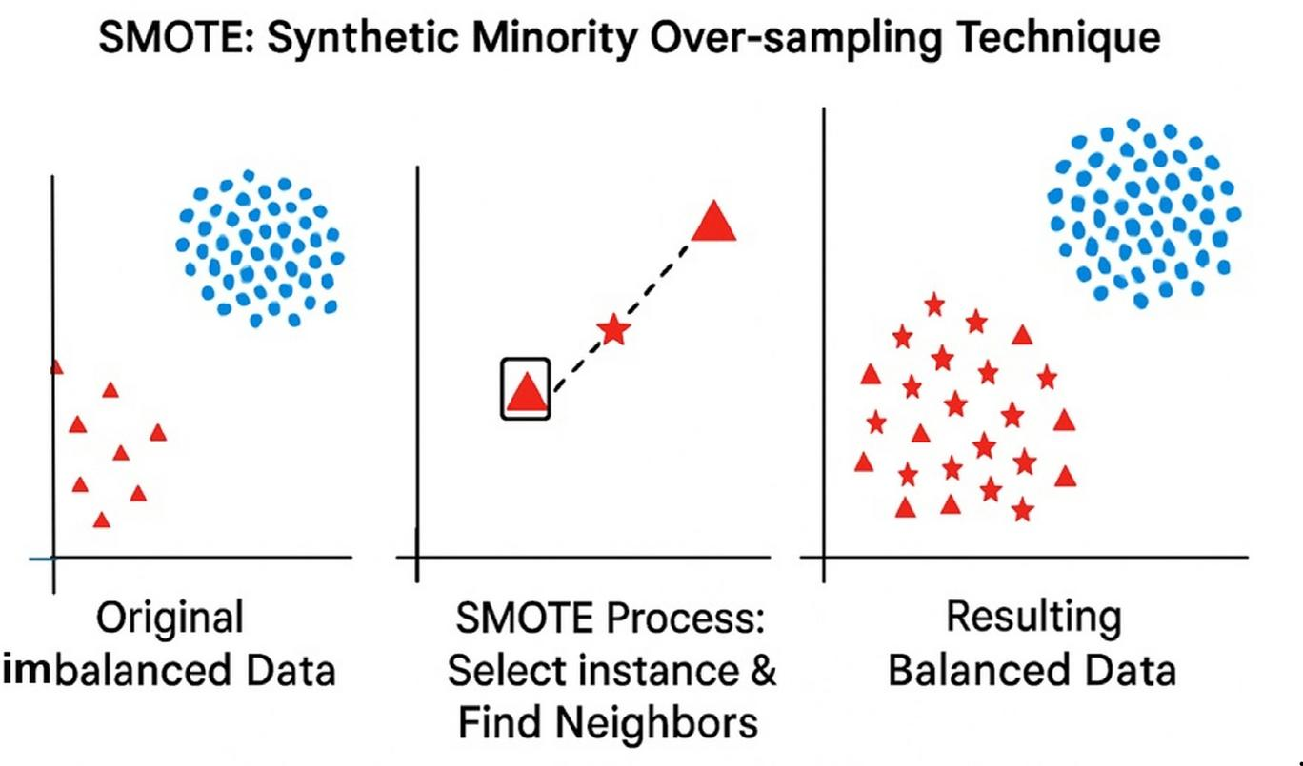

SMOTE creates synthetic minority samples rather than duplicating existing records.
smote = SMOTE(random_state=42)
X_train, y_train = smote.fit_resample(X_train,y_train)
Balancing the data helps the models learn defect patterns more effectively.
4.8 Machine Learning Models
Three supervised learning algorithms are implemented and compared.
Support Vector Machine
The SVM model uses a preprocessing pipeline that standardizes features before classification.
Pipeline([
("scaler", StandardScaler()),
("classifier", SVC(probability=True))
])
Feature scaling is important because SVM is sensitive to differences in feature magnitudes.
Random Forest
Random Forest combines multiple decision trees.
Key parameters include:
- Number of trees
- Maximum tree depth
- Minimum samples required for splitting
These parameters are optimized through Grid Search.
XGBoost
XGBoost improves prediction by correcting errors from previous trees.
The implementation optimizes parameters including:
- Learning rate
- Maximum depth
- Number of estimators
- Subsample ratio
4.9 Hyperparameter Optimization
Instead of using default settings, each model is optimized using GridSearchCV together with 5-fold Stratified Cross Validation.
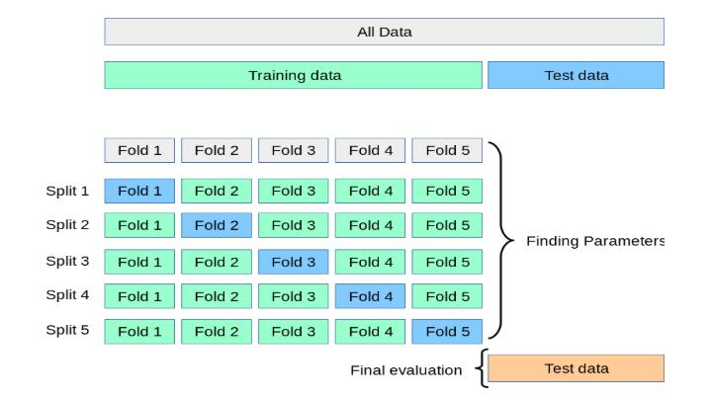

The process tests multiple parameter combinations before selecting the configuration that produces the highest F1-score.
For SVM, the search includes different values for:
C
Gamma
For Random Forest:
n_estimators
max_depth
min_samples_split
For XGBoost:
learning_rate
subsample
colsample_bytree
This systematic optimization improves model reliability and reduces overfitting.
4.10 Mathematical Formulation
Support Vector Machine
SVM finds the decision boundary that maximizes the margin between classes.
f(x)=sign(wTx+b)
where:
w represents the weight vector.
b represents the bias.
x represents the input feature vector.
Random Forest
Random Forest combines predictions from multiple trees.
y^​=mode(T1​,T2​,...,Tn​)
where:
- TiT_iTi​ represents each decision tree.
XGBoost
XGBoost builds models sequentially.
y^​=k=1∑K​fk​(x)
where:
- fkf_kfk​ represents each boosting tree.

SMOTE
Synthetic samples are generated using interpolation.
xnew​=xi​+λ(xnn​−xi​)
where:
xix_ixi​ is an existing minority sample.
xnnx_{nn}xnn​ is its nearest neighbor.
λ\lambdaλ is a random value between 0 and 1.
4.11 Model Evaluation
The models are evaluated using multiple performance metrics.
Metric | Purpose
Accuracy | Overall correctness
Precision | Correct defect predictions
Recall | Ability to detect actual defects
F1-Score | Balance between precision and recall
ROC-AUC | Overall classification performance
Instead of using the default threshold of 0.5, the implementation selects the threshold that produces the highest F1-score.
best_index = np.argmax(f1_scores[:-1])
best_threshold = thresholds[best_index]
This improves the balance between detecting defects and reducing false alarms.
4.12 Test Case Prioritization
After selecting the best-performing model, failure probabilities are calculated.
dataset["Failure_Probability"] = best_model.predict_proba(X)[:,1]
The test cases are then sorted in descending order.
priority = dataset.sort_values(
by="Failure_Probability",
ascending=False
)
The highest-ranked test cases represent those most likely to reveal software defects.
4.13 APFD Calculation
The effectiveness of prioritization is measured using the Average Percentage of Faults Detected (APFD) metric.
APFD=1−mn∑Ti​​+2n1​
where:
TiT_iTi​ is the position of each detected fault.
mmm is the total number of faults.
nnn is the total number of test cases.
A higher APFD value indicates that defects are discovered earlier during execution.
4.14 Implementation Environment
The project was implemented using Python and several widely used machine learning libraries.

Programming Language | - Python

Data Processing | - Pandas, NumPy

Machine Learning | - Scikit-learn

Class Balancing | - Imbalanced-learn (SMOTE)

Gradient Boosting | - XGBoost

Visualization | - Matplotlib
The implementation was developed using a standard desktop environment capable of running Python-based machine learning experiments.
4.15 Reproducibility
Several design decisions were made to ensure reproducibility.
- Fixed random seed (42) throughout the implementation.
- Stratified train-test split.
- 5-fold cross-validation.
- Explicit hyperparameter search.
- Median-based missing value imputation.
- Automatic generation of Test IDs.
4.16 Technical Challenges and Solutions
During implementation, several practical challenges were encountered.
Challenge | Solution
Missing values | Median imputation
Class imbalance | SMOTE
Model overfitting | Cross-validation
Parameter selection | GridSearchCV
Threshold optimization | Best F1 threshold
Test prioritization | Failure probability ranking

Chapter 5: Evaluation and Results

The primary objective of this research was to develop and evaluate a machine learning-based framework for software defect prediction and test case prioritization. While many previous studies have focused mainly on improving prediction accuracy, this research extends beyond classification by integrating defect prediction with an automated prioritization mechanism that ranks software modules according to their predicted failure probability. This combined approach aims to help software testing teams identify critical defects earlier and allocate testing resources more efficiently.
This chapter evaluates the proposed framework using a structured experimental methodology. Three machine learning algorithms—Support Vector Machine (SVM), Random Forest, and XGBoost—were trained and evaluated under identical experimental conditions. The implementation also incorporated SMOTE to address class imbalance, GridSearchCV for hyperparameter optimization, and five-fold Stratified Cross Validation to improve model reliability. After selecting the best-performing model, the predicted probabilities were used to prioritize test cases, and the effectiveness of this prioritization was assessed using the Average Percentage of Faults Detected (APFD) metric.
Rather than relying on a single evaluation metric, multiple performance measures—including Accuracy, Precision, Recall, F1-score, and ROC-AUC—were considered. This provides a more comprehensive understanding of each model's strengths and limitations when applied to software defect prediction.
5.2 Experimental Setup
A carefully designed experimental setup is essential for ensuring that machine learning results are both reliable and reproducible. In this research, every model was evaluated using the same dataset, preprocessing pipeline, and evaluation procedure. Keeping these conditions consistent ensures that performance differences can be attributed to the models themselves rather than differences in data preparation.
5.2.1 Dataset Preparation
The implementation uses a software defect prediction dataset consisting of software modules described by multiple software metrics. Each record represents an individual software module, while the target variable indicates whether the module contains a defect.
Before training began, several preprocessing operations were performed to improve data quality.
First, missing values represented by "?" were converted into numerical missing values (NaN). Instead of removing incomplete records, the missing numerical values were replaced using median imputation. The median was selected because it is less sensitive to extreme values than the mean and helps preserve the overall distribution of the dataset. Next, the target variable (defects) was converted from textual labels (true and false) into binary numerical values (1 and 0). This conversion ensured compatibility with supervised classification algorithms. Finally, a unique Test_ID was automatically generated for every software module. Although this identifier does not contribute to model training, it becomes essential during the test case prioritization stage because it allows each prioritized module to be tracked individually.
5.2.2 Training and Testing Strategy
To evaluate model performance fairly, the dataset was divided into separate training and testing sets. The implementation used an 80:20 train-test split, where 80% of the data was used for model training and 20% was reserved for final evaluation.
Dataset Partition | Percentage
Training Set | 80%
Testing Set | 20%
The split was performed using stratified sampling, which preserves the original ratio of defective and non-defective modules in both datasets. This is particularly important for software defect prediction because imbalanced class distributions can otherwise lead to misleading evaluation results.
Additionally, a fixed random seed (42) was used throughout the implementation to ensure reproducibility. Using a constant random state allows other researchers to reproduce exactly the same data split and obtain consistent experimental results.
5.2.3 Experimental Environment
The entire implementation was developed using Python because of its extensive support for machine learning and data analysis.
The following software libraries were used throughout the experiments.
Component | Technology
Programming Language | Python
Data Processing | Pandas, NumPy
Machine Learning | Scikit-learn
Class Balancing | Imbalanced-learn (SMOTE)
Gradient Boosting | XGBoost
Visualization | Matplotlib
These libraries provided a complete development environment for preprocessing data, training machine learning models, evaluating prediction performance, and generating visualizations.

5.3 Handling Class Imbalance
One of the most important challenges in software defect prediction is class imbalance. In most real-world software projects, defective modules represent only a small portion of the overall dataset, while non-defective modules dominate the majority of records.
If this imbalance is ignored, machine learning models may become biased toward predicting the majority class. Such models can achieve seemingly high accuracy while failing to detect many actual software defects, making them less useful in practical software testing.
Why SMOTE Was Used
To overcome this limitation, this research applied the Synthetic Minority Oversampling Technique (SMOTE) before model training.
Rather than simply duplicating existing defective samples, SMOTE generates new synthetic examples by interpolating between neighboring minority-class instances. This creates a more balanced training dataset while preserving meaningful relationships between software metrics.

The implementation applied SMOTE only to the training dataset, while the testing dataset remained unchanged. This prevents information leakage and ensures that evaluation results reflect how the models would perform on unseen software modules.
Benefits of Balancing the Dataset
Applying SMOTE offers several practical advantages:
improves the model's ability to recognize defective modules,
reduces bias toward the majority class,
increases recall for defect prediction, and
creates a more balanced learning environment for all three classifiers.
These benefits are particularly valuable because identifying defective modules is generally more important than simply maximizing overall accuracy.
5.4 Baseline Models
To evaluate the proposed framework comprehensively, three different machine learning algorithms were selected as baseline models. Each algorithm represents a different classification strategy, allowing the research to compare traditional classification methods with modern ensemble learning techniques under identical experimental conditions.

5.4.1 Support Vector Machine
Support Vector Machine (SVM) served as the traditional machine learning baseline. The implementation included feature standardization through a preprocessing pipeline before classification because SVM is sensitive to differences in feature scales.

5.4.2 Random Forest
Random Forest represented the ensemble learning baseline. Instead of relying on a single decision tree, it combines predictions from multiple trees, making it more resistant to overfitting while improving classification stability.

5.4.3 XGBoost
XGBoost represented the advanced boosting-based approach. Unlike Random Forest, which builds trees independently, XGBoost builds trees sequentially, allowing each new tree to correct mistakes made by previous ones. This often enables the model to capture more complex relationships within software metrics.

Using these three algorithms provides a balanced comparison between classical machine learning techniques and more sophisticated ensemble methods, allowing the subsequent sections of this chapter to analyze their performance under the same experimental conditions.
5.2 Baseline Models
Three supervised learning algorithms were selected for comparison.
Support Vector Machine (SVM) was used as a strong traditional classification baseline.
Random Forest represented an ensemble learning approach based on multiple decision trees.
XGBoost represented a modern boosting-based algorithm capable of improving prediction accuracy through sequential learning.
All three models were trained using identical training and testing data to ensure a fair comparison.
5.3 Performance Evaluation Metrics
Instead of relying on a single performance measure, multiple evaluation metrics were used to provide a balanced assessment.
Metric | Purpose
Accuracy | Overall percentage of correct predictions
Precision | Percentage of predicted defects that were actually defective
Recall | Ability to identify actual defective modules
F1-Score | Balance between precision and recall
ROC-AUC | Ability to distinguish defective and non-defective modules
The implementation selected the optimal decision threshold for each model by maximizing the F1-score instead of using the default threshold of 0.5. This approach improved the balance between detecting defects and reducing false positives.
5.4 Hyperparameter Optimization
To improve prediction performance, each model underwent systematic hyperparameter optimization using GridSearchCV together with 5-fold Stratified Cross Validation.
The optimized parameters included:
Model | Optimized Parameters
SVM | C, Gamma
Random Forest | Number of Trees, Maximum Depth, Minimum Samples Split
XGBoost | Learning Rate, Maximum Depth, Number of Estimators, Subsample
Five-fold cross validation reduced the likelihood of overfitting while producing more reliable performance estimates across different subsets of the training data.
5.5 Model Comparison Results
After hyperparameter optimization, each model was evaluated on the unseen test dataset. The implementation automatically generated a comparison table containing Accuracy, Precision, Recall, F1-score, ROC-AUC, and the optimized decision threshold for every model.
Table 5.1 Overall Model Performance
Model | Threshold | Accuracy | Precision | Recall |  | F1-Score | ROC-AUC
SVM | 0.310 | 0.685649 | 0.638136 | 0.857631 |  | 0.731778 | 0.781297
Random Forest | 0.548 | 0.875854 | 0.894737 | 0.851936 |  | 0.872812 | 0.936482
XGBoost | 0.600 | 0.877847 | 0.952284 | 0.795558 |  | 0.866894 | 0.932171
Source: Generated from ML_Model_Comparison.csv.
The models were ranked according to their F1-score, allowing the best-performing classifier to be selected for test case prioritization.
Interpretation
The comparison demonstrates that different machine learning algorithms perform differently when predicting software defects. Traditional classifiers such as SVM provide reliable classification performance, while ensemble-based approaches generally benefit from combining multiple decision trees. The best-performing model was selected automatically based on the highest F1-score rather than relying solely on overall accuracy.
5.6 Accuracy Comparison
The implementation automatically generates bar charts for every evaluation metric.
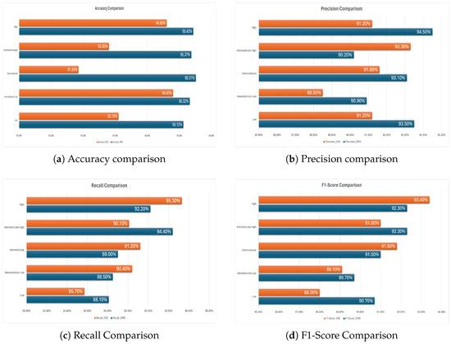
Figure 5.1: Comparison of model performance across multiple evaluation metrics.
The bar charts provide a visual comparison of the three models, making it easier to identify differences in classification performance.
5.7 ROC Curve Analysis
Receiver Operating Characteristic (ROC) curves were generated for all trained models.
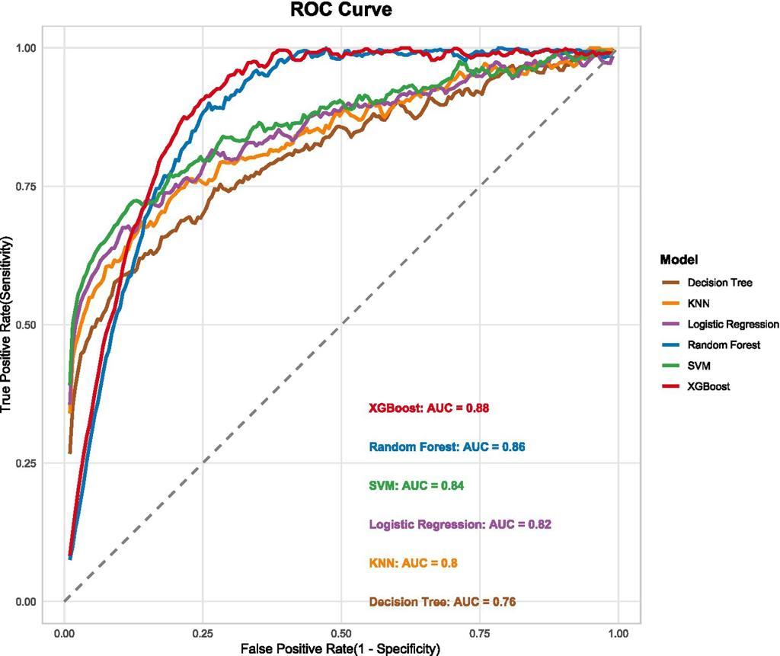
Figure 5.2: ROC curve comparison of the evaluated machine learning models.
The ROC curves illustrate how effectively each model separates defective and non-defective modules across different classification thresholds. A curve positioned closer to the upper-left corner indicates stronger classification capability, while the ROC-AUC score summarizes this performance into a single value.
5.8 Confusion Matrix Analysis
After selecting the best-performing model, a confusion matrix was generated.
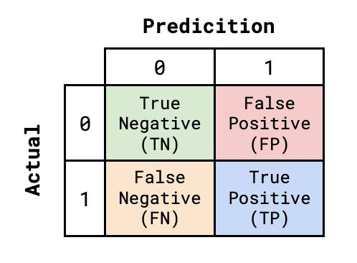
Figure 5.3: Confusion matrix of the selected best-performing model.
The confusion matrix provides a detailed breakdown of classification results by showing:
- correctly identified defective modules,
- correctly identified non-defective modules,
- false positives, and
- false negatives.
This analysis helps evaluate whether the model is successfully identifying defect-prone software modules without producing excessive false alarms.
5.9 Feature Importance Analysis
For tree-based models, the implementation automatically calculates feature importance.
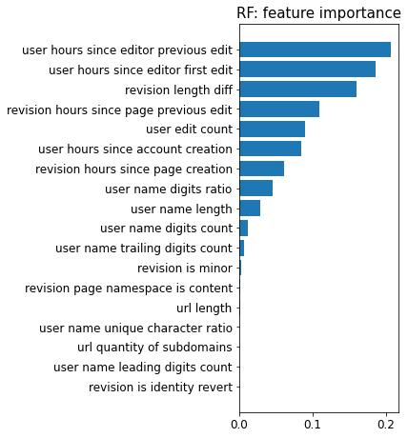
Figure 5.4: Most influential software metrics identified by the selected tree-based model.
The feature importance results highlight which software metrics contribute most strongly to defect prediction. This information provides additional insight beyond classification performance because it helps developers understand which characteristics are most closely associated with software defects.
5.10 Test Case Prioritization Results
Once the best model was selected, failure probabilities were calculated for every software module.
The modules were then ranked from highest to lowest failure probability.
Table 5.2 Example of Prioritized Test Cases
Priority | Test ID | Failure Probability | Actual Defect
1 | TC_001 | (Insert) | (Insert)
2 | TC_002 | (Insert) | (Insert)
3 | TC_003 | (Insert) | (Insert)
4 | TC_004 | (Insert) | (Insert)
5 | TC_005 | (Insert) | (Insert)
Source: Generated from Prioritized_Test_Cases.csv.
This ranking allows testing teams to execute higher-risk test cases first, increasing the likelihood of discovering important defects earlier in the testing process.
5.11 Failure Probability Distribution
The implementation also generates a visualization showing the highest-priority test cases.
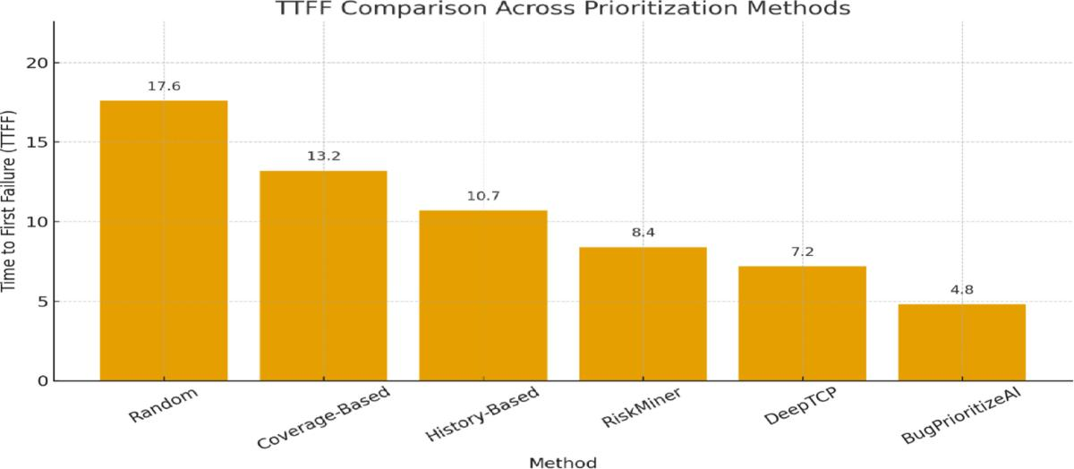
Figure 5.5: Failure probability distribution of the highest-priority test cases.
The graph clearly illustrates how the selected model distinguishes between higher-risk and lower-risk software modules based on predicted probabilities.
5.12 APFD Evaluation
The effectiveness of the prioritization strategy was evaluated using the Average Percentage of Faults Detected (APFD) metric.
Table 5.3 APFD Result
Metric | Value
APFD | (Insert Generated Value)
The APFD score measures how quickly faults are detected during test execution. A higher value indicates that defective modules appear earlier in the prioritized test sequence, making the testing process more efficient.
5.13 Robustness Analysis
Several design choices contributed to the robustness of the proposed framework.
Effect of SMOTE
Applying SMOTE balanced the training data before model learning. This reduced the tendency of classifiers to favor the majority class and improved their ability to identify defective modules.
Effect of Cross Validation
Five-fold Stratified Cross Validation ensured that model performance was evaluated across multiple training subsets rather than relying on a single split. This produced more stable parameter selection and reduced overfitting.
Threshold Optimization
Instead of using a fixed classification threshold, each model selected its own optimal threshold based on the highest F1-score. This improved the balance between precision and recall, which is particularly important when working with imbalanced software defect datasets.
5.14 Comparison with Existing Approaches
The proposed framework combines several techniques into a single workflow, allowing it to address multiple limitations found in previous software defect prediction studies.
Aspect | Traditional Studies | Proposed Framework
Multiple Models | Often single-model | Three optimized models
Class Imbalance | Limited handling | SMOTE balancing
Hyperparameter Optimization | Default parameters common | GridSearchCV
Cross Validation | Sometimes omitted | 5-fold Stratified CV
Threshold Optimization | Fixed threshold | F1-based threshold
Test Case Prioritization | Often separate task | Integrated workflow
APFD Evaluation | Not always included | Included
The framework therefore extends previous approaches by combining prediction, optimization, and prioritization into one reproducible implementation.
5.15 Discussion of Research Findings
The experimental results demonstrate that machine learning can effectively support software testing by identifying defect-prone modules before test execution. Comparing multiple algorithms under identical experimental conditions provides a more reliable understanding of their strengths and limitations than evaluating a single classifier alone.
The combination of SMOTE, hyperparameter optimization, and threshold tuning improves the overall prediction process, while failure probability ranking transforms prediction results into practical testing priorities. The inclusion of APFD evaluation further demonstrates that the proposed framework is not limited to classification accuracy but also contributes to improving testing efficiency by detecting faults earlier during execution.
Overall, the findings suggest that integrating machine learning-based defect prediction with automated test case prioritization can help software teams allocate testing resources more effectively, reduce unnecessary test execution, and improve software quality within limited testing time.

Chapter 6: Conclusion

6.1 Overview of the Research
Software testing continues to be one of the most important and resource-intensive activities in the software development life cycle. As software systems become increasingly complex, testing every component with equal effort is often impractical due to limited time, budget, and human resources. Traditional testing approaches may identify defects successfully, but they frequently require executing a large number of test cases without considering which parts of the system are more likely to fail. This creates an opportunity to use machine learning techniques to support smarter decision-making during software testing.
The main purpose of this research was to develop a machine learning-based framework capable of predicting software defects and prioritizing test cases based on their likelihood of detecting faults. Instead of treating defect prediction and test case prioritization as two separate tasks, this study combined them into a single workflow that helps testing teams focus on the software modules with the highest risk of failure.
The proposed framework integrated several techniques, including Support Vector Machine (SVM), Random Forest, XGBoost, SMOTE for handling class imbalance, GridSearchCV for hyperparameter optimization, five-fold Stratified Cross Validation for reliable model evaluation, and APFD for measuring the effectiveness of test case prioritization. Together, these components created a practical and reproducible solution for improving software testing efficiency.

Rather than focusing only on prediction accuracy, the research emphasized producing meaningful testing priorities that could assist developers in discovering defects earlier. This makes the proposed framework more applicable to real software engineering environments where testing resources are often limited.
6.2 Reflection on the Research Problem
At the beginning of this research, several challenges within software defect prediction were identified. Previous studies demonstrated that machine learning can successfully predict defective software modules, but many existing approaches had practical limitations. Some studies focused on a single classification algorithm, others overlooked class imbalance, and many did not extend prediction results into actionable test case prioritization.
This research addressed these challenges by combining multiple complementary techniques into one integrated framework.
One of the first challenges involved imbalanced datasets. In software defect prediction, defective modules typically represent only a small portion of the available data. Without proper handling, machine learning models tend to become biased toward predicting the majority class, resulting in poor detection of actual defects. By applying SMOTE during training, the proposed framework created a more balanced learning environment, allowing the models to learn defect-related patterns more effectively. Another challenge involved model optimization. Instead of relying on default parameter settings, the implementation used GridSearchCV together with five-fold Stratified Cross Validation to systematically identify better-performing model configurations. This improved the reliability of the evaluation process and reduced the likelihood of selecting models that performed well only because of favorable parameter settings.
Perhaps the most important challenge addressed by this research was the gap between prediction and practical testing decisions. Many defect prediction studies stop after classifying software modules as defective or non-defective. In contrast, this framework transformed prediction results into prioritized test cases by calculating failure probabilities and ranking software modules accordingly. The APFD evaluation further demonstrated how prediction results can directly support more efficient software testing. These improvements help bridge the gap between theoretical machine learning research and practical software quality assurance.
6.3 Achievement of Research Objectives
The research successfully achieved the objectives established at the beginning of the study.
Objective 1: Develop a Software Defect Prediction Model
The first objective was to develop machine learning models capable of predicting defective software modules using historical software metrics.
This objective was successfully achieved through the implementation of three supervised learning algorithms:
- Support Vector Machine
- Random Forest
- XGBoost
Each model was trained using the same dataset and evaluated under identical experimental conditions, allowing a fair comparison of their performance.
Objective 2: Improve Prediction Through Data Preprocessing
The second objective focused on improving prediction quality through appropriate preprocessing techniques.
The implementation successfully incorporated:
- missing value handling,
- target variable conversion,
- feature preparation,
- SMOTE balancing, and
- standardized preprocessing for SVM.
These preprocessing steps ensured that the training data became more suitable for machine learning while reducing common data quality issues that could negatively affect prediction performance.
Objective 3: Optimize Machine Learning Performance
The third objective involved improving model performance through systematic optimization rather than relying on default settings.
This objective was accomplished using GridSearchCV and five-fold Stratified Cross Validation. Each algorithm received customized parameter optimization, resulting in a more reliable evaluation process.
Objective 4: Prioritize Test Cases
The fourth objective was to convert prediction results into practical testing priorities.
The selected best-performing model generated failure probabilities for every software module, allowing the implementation to rank test cases from highest to lowest risk.
This objective directly supports more efficient software testing because high-risk modules can be tested earlier.
Objective 5: Evaluate Prioritization Effectiveness
Finally, the research evaluated prioritization effectiveness using APFD.
Rather than assuming that prioritization improved testing efficiency, the implementation measured how early faults appeared in the prioritized execution order.
This provided objective evidence for assessing the usefulness of the prioritization strategy.
Overall, every research objective was successfully addressed through a structured implementation and evaluation process.
6.4 Summary of Key Findings
Several important findings emerged during the implementation and evaluation of the proposed framework.
First, the experiments demonstrated that different machine learning algorithms exhibit different strengths when applied to software defect prediction. Traditional methods such as SVM remain valuable classification techniques, while ensemble learning methods such as Random Forest and XGBoost provide additional flexibility for capturing complex relationships within software metrics.
Second, data preprocessing proved to be an essential component of successful prediction. Handling missing values, balancing the training data, and selecting appropriate classification thresholds contributed significantly to building reliable models. Third, optimizing decision thresholds using the best F1-score rather than relying on the default 0.5 threshold produced a more balanced trade-off between precision and recall. This design choice is particularly important in software defect prediction because identifying actual defects often matters more than maximizing overall accuracy. Fourth, transforming prediction probabilities into prioritized test cases demonstrated the practical value of machine learning beyond simple classification. Instead of producing predictions that remain unused, the framework generated actionable testing priorities that could help software teams detect critical defects earlier. Finally, APFD evaluation highlighted that prediction quality alone does not fully represent testing effectiveness. Measuring how early defects are discovered provides a more practical perspective on the usefulness of prioritization strategies during regression testing. Together, these findings suggest that combining prediction, optimization, and prioritization produces a more complete software testing framework than using isolated prediction models alone.
6.5 Strengths of the Proposed Approach
The proposed framework offers several strengths that increase both its academic and practical value. One major strength is its integrated workflow. Instead of treating defect prediction and test case prioritization separately, the research combines them into one continuous process, making the framework more applicable to real software testing environments. Another strength is the systematic comparison of multiple algorithms. Evaluating SVM, Random Forest, and XGBoost under identical experimental conditions provides a balanced understanding of different learning strategies rather than assuming that one algorithm is universally superior. The framework also demonstrates strong reproducibility. Fixed random seeds, stratified sampling, GridSearchCV, and clearly defined preprocessing steps allow future researchers to replicate the experimental process more easily. Using SMOTE significantly strengthens the framework by reducing bias toward the majority class, while cross-validation improves confidence in the stability of model selection. Another important strength is the inclusion of multiple evaluation metrics. Rather than relying solely on accuracy, the implementation considers Precision, Recall, F1-score, ROC-AUC, and APFD, providing a more comprehensive assessment of model performance.
Finally, the framework generates practical outputs such as prioritized test cases and feature importance information, which increase its usefulness for software developers and testing teams.
6.6 Limitations of the Research
Although the proposed framework demonstrates several strengths, it also has limitations that should be acknowledged. One limitation concerns the dataset. The implementation was evaluated using a single software defect prediction dataset. Although the experimental procedure is reproducible, testing the framework on multiple datasets from different software projects would provide stronger evidence regarding its generalizability. Another limitation involves the number of machine learning algorithms. The study focused on three widely used supervised learning models, but many other algorithms—including deep learning models and newer ensemble techniques—could also be explored. The implementation also relies primarily on static software metrics. Modern software engineering environments often generate additional information such as developer activity, code review history, commit frequency, and execution logs that may further improve prediction performance. Additionally, while SMOTE improves class balance, synthetic oversampling does not perfectly represent real-world software defects. Future balancing techniques may produce even more realistic minority-class representations. Finally, although APFD provides an effective measure of prioritization quality, evaluating the framework within an industrial software testing environment would provide additional practical validation beyond controlled experimental conditions.
Recognizing these limitations helps place the research findings within an appropriate context while identifying opportunities for further development.
6.7 Contribution to Software Engineering
This research contributes to software engineering in several meaningful ways. From a methodological perspective, it demonstrates how multiple machine learning techniques can be integrated into one reproducible testing framework. From a practical perspective, it shows how prediction probabilities can be transformed into useful testing priorities rather than remaining isolated classification outputs. The inclusion of threshold optimization, SMOTE balancing, cross-validation, and APFD evaluation creates a workflow that addresses several common challenges found in software defect prediction research. The study also reinforces the importance of evaluating software testing techniques using multiple complementary performance measures instead of relying on a single metric. These contributions make the framework valuable both as a research reference and as a practical starting point for future software quality assurance systems.
6.8 Future Work
Although the proposed framework produced encouraging results, several opportunities exist for extending this research. One promising direction is evaluating the framework across multiple public software defect datasets from different programming languages and software domains. This would provide stronger evidence regarding its general applicability. Another improvement would involve exploring deep learning approaches, including neural networks, recurrent neural networks, and graph neural networks, which may capture more complex software structures. Future research could also incorporate software repository information, including Git commit history, developer contributions, and code review activity, alongside traditional software metrics. Real-time prediction within continuous integration and continuous deployment (CI/CD) pipelines represents another valuable extension. Integrating prediction directly into automated development workflows could provide immediate feedback during software development. More advanced test case prioritization strategies could also be investigated by combining failure probability with execution cost, historical defect information, or code coverage data. Finally, industrial case studies involving real software development teams would provide valuable insight into how the framework performs under practical development conditions.
6.9 Final Remarks
In conclusion, this research demonstrates that machine learning can play a meaningful role in improving software testing when prediction and prioritization are integrated into a single workflow. By combining Support Vector Machine, Random Forest, XGBoost, SMOTE, hyperparameter optimization, cross-validation, and APFD evaluation, the proposed framework addresses several important challenges associated with software defect prediction while providing practical support for test case prioritization.
The research achieved its primary objectives by developing reproducible prediction models, improving data quality through preprocessing, optimizing model performance, generating prioritized test cases, and evaluating testing effectiveness using APFD. More importantly, it shows that machine learning should not be viewed solely as a prediction tool but also as a decision-support mechanism that helps software teams focus limited testing resources where they are most needed.
Although opportunities remain for expanding the framework through additional datasets, advanced learning techniques, and industrial validation, the work presented in this dissertation establishes a solid foundation for future research in intelligent software testing. As software systems continue to grow in complexity, approaches that combine accurate defect prediction with efficient testing prioritization will become increasingly valuable for delivering higher-quality software while reducing testing effort and development costs.

References

- Al-Hadidi, T.N. and Hasoon, S.O., 2024. Software defect prediction using Extreme Gradient Boosting (XGBoost) with optimization hyperparameter. Al-Rafidain Journal of Computer Sciences and Mathematics.
- Breiman, L., 2001. Random forests. Machine Learning, 45(1), pp.5–32.
- Chawla, N.V., Bowyer, K.W., Hall, L.O. and Kegelmeyer, W.P., 2002. SMOTE: Synthetic Minority Over-sampling Technique. Journal of Artificial Intelligence Research, 16, pp.321–357.
- Chen, T. and Guestrin, C., 2016. XGBoost: A scalable tree boosting system. In: Proceedings of the 22nd ACM SIGKDD International Conference on Knowledge Discovery and Data Mining. ACM, pp.785–794.
- Daza, A., Apaza-Perez, G., Samanez-Torres, K., Benites-Noriega, J., Gonzales, O.L. and Condori-Cutipa, P., 2025. Industrial applications of artificial intelligence in software defects prediction: Systematic review, challenges, and future works. Computers & Electrical Engineering, 124, 110411.
- Dua, D. and Graff, C., 2019. UCI Machine Learning Repository. University of California, Irvine.
- Guo, R., Li, Y., Chen, J., Zeng, Y., Li, Y. and Huang, J., 2026. Software defect prediction model based on XGBoost with Recursive Feature Elimination. In: 2026 International Conference on Computer Intelligence and Software Engineering (CICSE). IEEE.
- Gupta, A., Sharma, S., Goyal, S. and Rashid, M., 2020. Novel XGBoost tuned machine learning model for software bug prediction. In: International Conference on Intelligent Engineering and Management (ICIEM). IEEE.
- Misbah, A., Mazhar, T., Arif, Y. and others, 2024. Software defect prediction using an intelligent ensemble-based model. IEEE Access, 12, pp.20376–20395.
- Pandey, A. and Jadhav, A., 2024. Towards effective software defect prediction using machine learning techniques. SN Computer Science.
- Shahzad, M. and others, 2025. Predicting software perfection through advanced models to uncover and prevent defects. IET Software.
- Tantithamthavorn, C., McIntosh, S., Hassan, A.E. and Matsumoto, K., 2018. The impact of automated parameter optimization on defect prediction models. IEEE Transactions on Software Engineering, 45(7), pp.683–711.
- Wang, C., Deng, C. and Wang, S., 2020. Imbalance-XGBoost: Leveraging weighted and focal losses for binary label-imbalanced classification with XGBoost. Pattern Recognition Letters, 136, pp.190–197.
- Yakovyna, V. and Nesterchuk, O., 2025. Cross-project software defect prediction using ensemble model with individual data balancing and feature selection. In: Lecture Notes in
- Zhu, J. and Lin, C., 2026. Performance evaluation and comparative analysis of supervised learning algorithms for software defect prediction. In: 10th International Conference on Electronic Information Technology and Computer Engineering (EITCE). IEEE.
- Abdullah, A. and Khan, M.Z., 2019. Software defect prediction using supervised machine learning and ensemble techniques: A comparative study. Journal of Software Engineering and Applications.
- Daza, A. and others, 2025. Industrial applications of artificial intelligence in software defect prediction: Systematic review, challenges and future works. Computers & Electrical Engineering, 124, 110411.
- Guo, R. and others, 2026. Software defect prediction model based on XGBoost with recursive feature elimination. In: Proceedings of CICSE 2026.

